Dr. Reevesinator GoogleHappy Status Report

4/13/20

**TESTS**

Test 26: Places a single user into a team then asserts that their preference is correctly inserted

Test 27: Places generic names with empty spaces into preferences then asserts based on three-dimensional matrix

Test 28: Tests usernames to be certain it accepts properly.

Test 29: Tests user happiness and makes certain it rounds properly

Test 30: Places strings into preference array then tests user happiness.

Test 31: Test 30 without testing user happiness function

**RELEASE WALL**

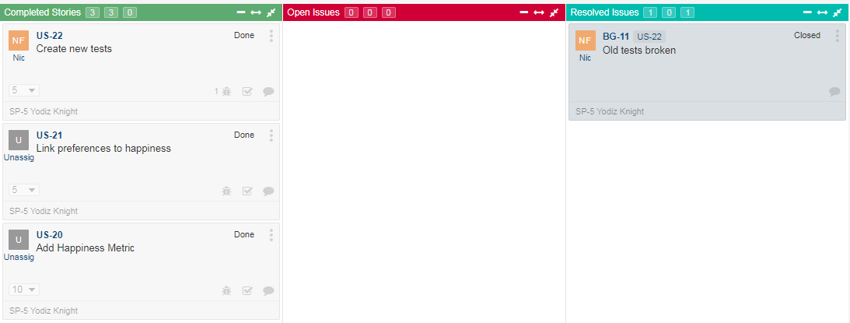

**STORYBOARD**

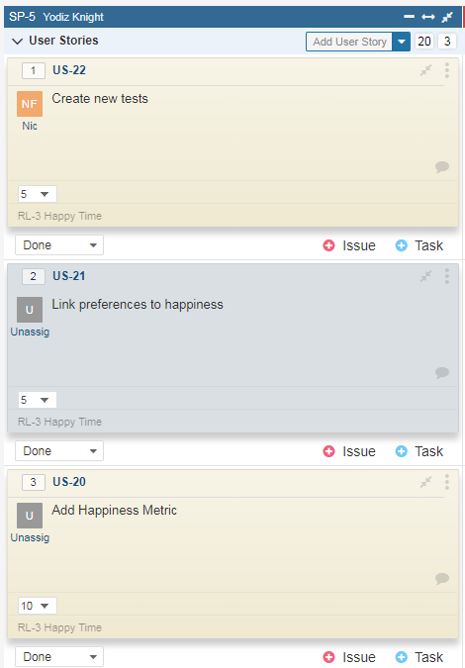

**CONTRIBUTION**

Ben: 40%

Nic 45%

Wade: 15%

**UPDATED THINGS**

Happiness system properly made, assigns total happiness based on preferences. ‘A’ proposal accepted.

